**STAT 40001/STAT 59800 Statistical Computing Fall 2020**

**Lab-15**

1. Thirteen Honda Accord are chosen to study the gas mileage. Below is the mpg for these vehicles.

27 26 31 30 30 28 26 24 30 30 23 30 23

Perform a test to see whether the data is coming from a normal distribution.

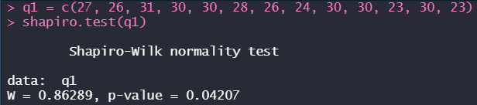  
 *(From p-value we can reject the null hypothesis and say that the sample data are significantly different from a normal distribution)*

1. An article at Mobilize.org reported that the median credit-card balance for undergraduate students was $1770 for those who carried a balance from month to month. A professor at a community college believes that the median credit-card balance of students at his college is different than $1770. To test this hypothesis, he obtains a random sample of 20 students enrolled at the college who carry a credit-card balance from month to month and asks them to disclose their credit-card debt. The results of the survey are presented in Table 3 in dollars. Do the data indicate that the median credit-card debt of students at the professor's college differs from $1770 at the α=0.05 level of significance?

|  |  |  |  |
| --- | --- | --- | --- |
| 6000 | 870 | 1530 | 1660 |
| 1060 | 1790 | 1630 | 3180 |
| 2180 | 2370 | 1800 | 2170 |
| 1210 | 410 | 1720 | 1270 |
| 570 | 1050 | 2320 | 1120 |

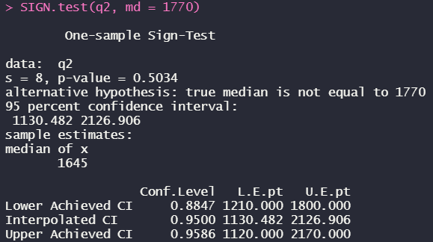

*(The p-value is greater than the significance level so that we can’t reject the null hypothesis that the median debt of students is equal to $1770)*

1. The exec.pay data in UsingR library contains data on salaries of CEOs at 199 top companies in the United States. The amount are in $10,000s. Do a sign test to determine whether the median pay is more than $220,000.

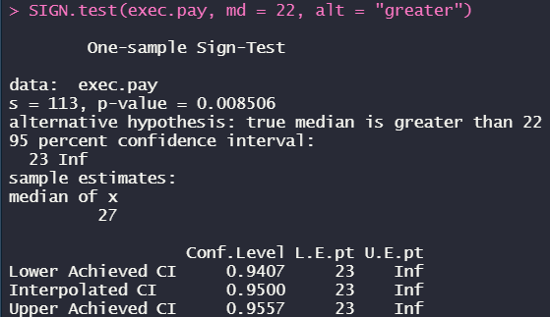

*(p-value is less than the significance level such that we can reject the null hypothesis and say that the median pay is more than $220,000)*